- Screen shots
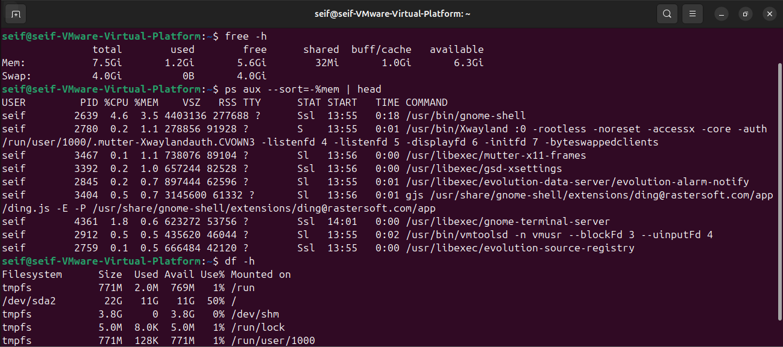

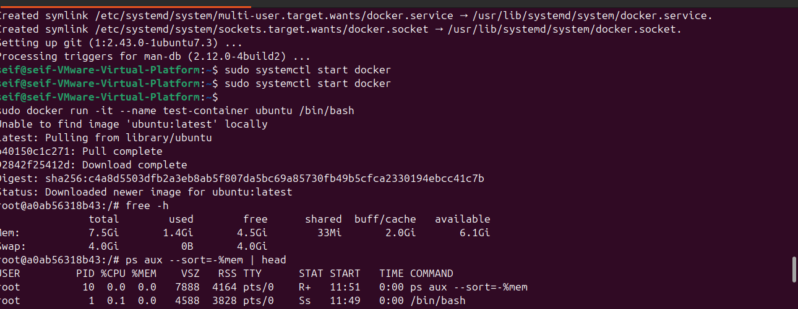

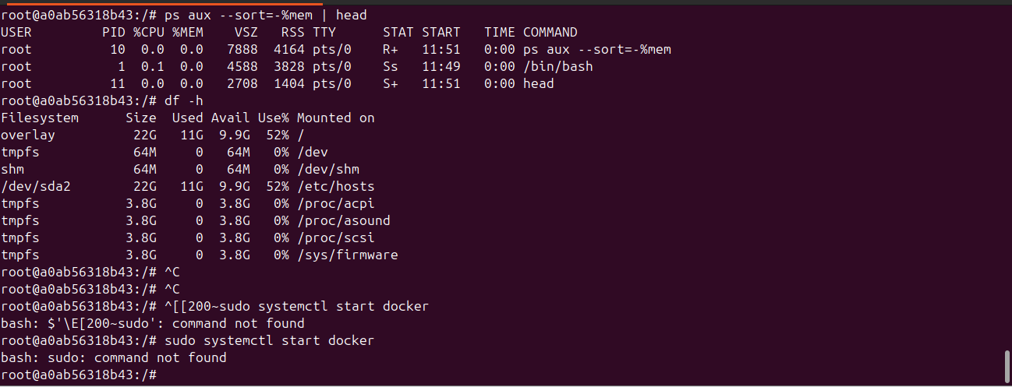

- Latency histogram or results
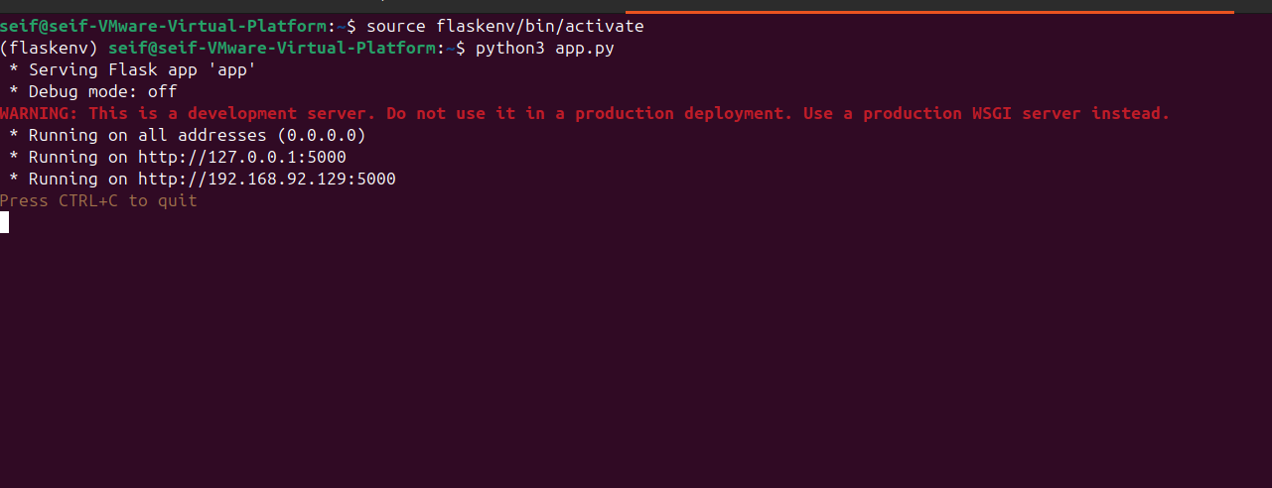

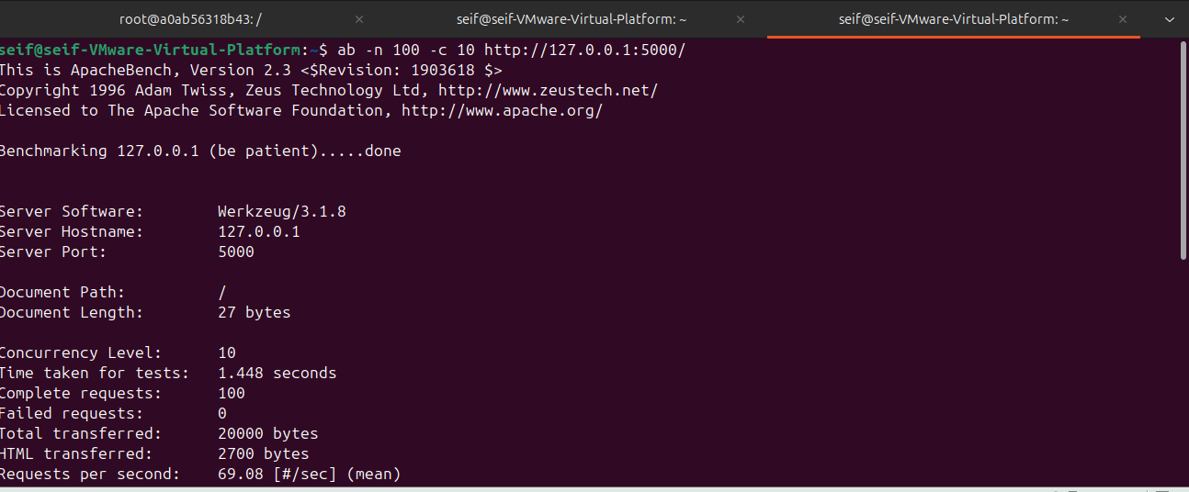

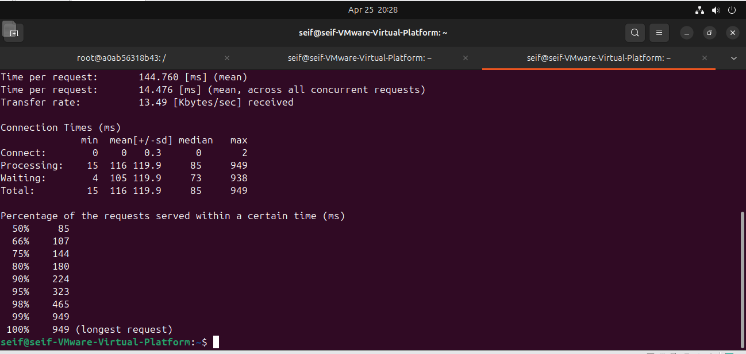

1. Why does AWS split Nitro into hardware components?
Amazon Web Services separates the AWS Nitro System into dedicated hardware components to improve security, performance, and scalability.
Traditional hypervisors handle networking, storage, and management within the host CPU, which can consume resources and increase the attack surface. By offloading these functions to specialized Nitro cards, AWS reduces the workload on the main processor and allows customer instances to access nearly all host resources.
This hardware-based separation provides:
- Stronger isolation between customer instances
- Lower virtualization overhead
- Improved system performance
- Better scalability across cloud infrastructure
As a result, the Nitro architecture enables AWS to deliver cloud instances that behave more like physical servers while maintaining cloud flexibility.

2. In which scenarios would virtual machines be preferred over containers?
Virtual machine are generally preferred over Docker containers when a workload requires full operating system isolation or compatibility with legacy software.
Virtual machines are more suitable in the following scenarios:
- Running different operating systems on the same physical host
- Supporting legacy applications that depend on a specific kernel
- Hosting workloads that require strong security boundaries
- Environments needing strict compliance or regulatory separation
- Testing complete operating systems in research or development
Containers share the host operating system kernel, making them lightweight, but this shared architecture can limit compatibility for some applications. Therefore, VMs remain the better choice when stronger isolation or broader OS support is required.

3. How does tail latency change with the number of parallel calls?
In distributed systems, tail latency increases as the number of parallel service calls grows. Tail latency refers to the slowest responses, such as the 95th or 99th percentile response times.
When multiple requests are executed in parallel:
- Each service has a small chance of responding slowly
- The probability that at least one request becomes slow rises
- Overall application response time becomes dependent on the slowest component
For example:
- With 1 service call → low chance of delay
- With 10 parallel calls → higher chance one call is slow
- With 100 parallel calls → very high chance of a tail-latency event
This means that even if average latency stays low, the worst-case response time grows significantly as system fan-out increases. Cloud platforms often reduce this issue through request hedging, caching, and minimizing unnecessary parallel dependencies.

